Online Safety Newsletter

June 2026

Pinterest

You need to be at least 13 years old to use Pinterest.

Pinterest is a social media app, where users can share images and videos (called Pins). Users can browse through the images based on their stated interests, for example cooking. Users can then ‘pin’ (save) these images to their own boards to revisit.

There is content on Pinterest that is not suitable for young people to see. Also, did you know that there is a messaging element to it, so your child could be interacting with strangers? Therefore, if your child is using Pinterest, it is important to show your child how to use the blocking and reporting tools. You can find out more information, including how to set up parental controls here:
https://help.pinterest.com/en/article/resources-for-parents-and-caregivers-of-teens

Find out more here:
https://www.internetmatters.org/hub/news-blogs/what-is-pinterest-what-parents-need-to-know/

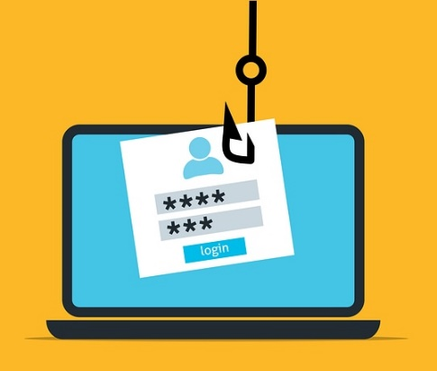
Online Scams

It is important to be aware that scammers can target your child whilst online through social media, messaging apps and games. These scams often look genuine, and children may not have the digital literacy skills to question their authenticity. This can happen across lots of platforms that your child is accessing, for example Roblox or TikTok. Scams can include:
- Offering in game currency.
- Befriending your child, which can then lead to requests for money or account details/personal information.
- Phishing links, with the intention of sharing malware or requesting account details/personal information.

What can I do?
It is important to have regular conversations with your child about what they are doing online and remind them to:
- Never share passwords or verification codes.
- Speak to you or another trusted adult if they are unsure about anything.
- Ensure appropriate parental controls and privacy settings are in place.
- Talk to your child about the different scams that can appear online and remind your child to check links before clicking on them.
- Remind your child that if they do think that they have been scammed, then to tell you straightaway.

Further information
https://parentzone.org.uk/article/how-deal-online-scams-parent-guide
Digital Footprints

When we go online, we create a digital footprint, which is a record of what we do online. This can be by visiting websites, sharing photos, liking or commenting on other people’s posts or playing games. It is important that children are aware of the digital footprint that they are creating and the lasting effect it can have. Childline provides further information about digital footprints, including advice on how to protect our privacy online:

https://www.childline.org.uk/info-advice/bullying-abuse-safety/online-mobile-safety/taking-care-your-digital-footprint/
Would you like to read this newsletter in a different language? You can use the translate tool on our web version:
https://www.knowsleyclcs.org.uk/june-2026-primary/

Storybooks and games from the BookTrust

BookTrust have a whole host of storybooks and games on their website. They have storybooks to read, story time videos to watch and kid’s games to play.

https://www.booktrust.org.uk/how-we-help/have-fun-at-home/storybooks-and-games/

Risks of Auto saving


Does your child use the likes of WhatsApp, which may automatically download any image/video that is sent to them to their phone’s own camera roll? We would advise switching this feature off.

Children may receive lots of photos/videos, particularly within group chats, that they have not requested. If auto download is allowed, then your child does not have control over what is being saved to their camera roll. Potentially, it may also be content that you would not want your child to have saved. Additionally, from a safeguarding perspective, if everything is automatically downloaded to your child’s camera roll, it can become difficult to ascertain the source of the image.
Emoji Meanings

Did you know that some children and young people may be using emojis to mean something completely different? For example, a cap emoji may be used to represent a lie. It is important that you are aware of how emojis can be used and keep up to date with the way in which they can be used as their meanings are changeable. You can find out further information here: https://www.bark.us/blog/emoji-slang-guide/

How can I disable this feature?
If your child is using a platform that allows this, then there is usually an option to disable this feature, so your child has control over the images saved to their device. The option to disable will be within the settings of the App, here is how to do this on WhatsApp:

- In WhatsApp, go to settings (click on ‘You’ in the bottom right).
- Click on ‘Chats’.
- Toggle ‘Save to Photos’ to off.

“Retro – Photos with Friends” App

Omoggle

Omoggle is an online platform that is for adults only. However, you can simply lie and say you are over 18 to access it. The platform joins two strangers together and uses AI to rate their appearances in a “mog battle.”

As you are paired up with a stranger and can see and hear them, there are serious safeguarding concerns and young people should not be accessing this site. Find out more here: https://www.waynedenner.com/omoggle-parent-guide/

This is a photo sharing app, and it is rated as 13+ by the App store. The aim of the app is users share their photos with close friends only, like a photo journal. Whilst it is marketed as a safer alternative to other social media apps, you do need to be aware of the following:

- Privacy and data access.
- It does include group chats so there is still the potential for cyberbullying and peer pressure.
- Users may feel safer sharing images as it is with close friends, but content can still be shared with others (through screenshots).

If your child is using this app, make sure you check that privacy settings are set up appropriately.

Users of this guide do so at their own discretion. No liability is entered into. Current as of the date released 01.06.26. The inclusion of any links does not imply any affiliation with or endorsement of the linked websites, documents, or videos, nor are we claiming any ownership or copyright in the content of the linked materials.

